DOKUZ EYLUL UNIVERSITY
ENGINEERING FACULTY
DEPARTMENT OF COMPUTER ENGINEERING

CME1251 PROJECT BASED LEARNING – I
FINAL REPORT
11-22-33

SHAPER

by
Bedirhan Karaahmetli
Deniz Katayıfçı
Veysel Karani Saydam

Lecturers
Doç. Dr. Semit UTKU
Arş. Gör. Fatih DİLMAÇ

IZMIR
01.12.2021

CHAPTER ONE
PROGRESS DESCRIPTION
The purpose of the game, earn high scores by matching numbers which automatically assigned by the system.
Game play, the system will automatically generate numbers. All you have to do is match the numbers using the direction and W-A-S-D keys. Then the numbers you matched will disappear and the system will create a new one.

CHAPTER TWO
TASK SUMMARY

Completed Tasks
Bedirhan Karaahmetli, moving numbers using W and S keys. Printing screen. Moving single number left or right with A and D keys. Remaining parts of the application. Testing and debugging.
Deniz Katayıfçı, numbers are randomly assigned. Creating the necessary variables. Controls matching numbers. Remaining parts of the application. Testing and debugging.
Veysel Karani Saydam, arrow keys movement is provided by using Setcursorposition command and consolkey command. Calculating the score. Remaining parts of the application. Testing and debugging.

CHAPTER THREE
EXPLANATION of algorıthms

Screenshots
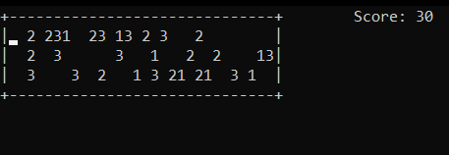

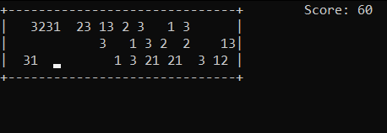

Functions
• Random
• ConsoleKey
• SetCursorPosition
• ConsoleKeyAvailable

Algorithms and Solution Strategies
• Made the game always playable using the "while" loop.
• "ConsoleKey" is used to read the keys entered by the user.
• We went around the playground with the for loop and checked for numbers that matched with if.

CHAPTER FOUR
PROBLEMS ENCOUNTERED
• Firstly we used two dimensional array. But later we convert it to one dimensional.
• We did’t know anything about Key commands. But later we learned.

CHAPTER FIVE
conclusıon
As a result, we made a functional game with teamwork. Teamwork has added us a lot. We also learned time management with this project. It has been a very productive work for us.
We learned and practiced arrays.

REFERENCES
https://www.w3schools.com/cs/cs_arrays.php
https://www.geeksforgeeks.org/console-setcursorposition-method-in-c-sharp/
https://docs.microsoft.com/tr-tr/dotnet/csharp/programming-guide/arrays/
https://stackoverflow.com/questions/46939267/reading-key-press-in-console-app
https://docs.microsoft.com/tr-tr/dotnet/api/system.consolekey?view=net-6.0
https://carbon.now.sh/
Google Images

AppendIx A
Poster/Web page of the Project
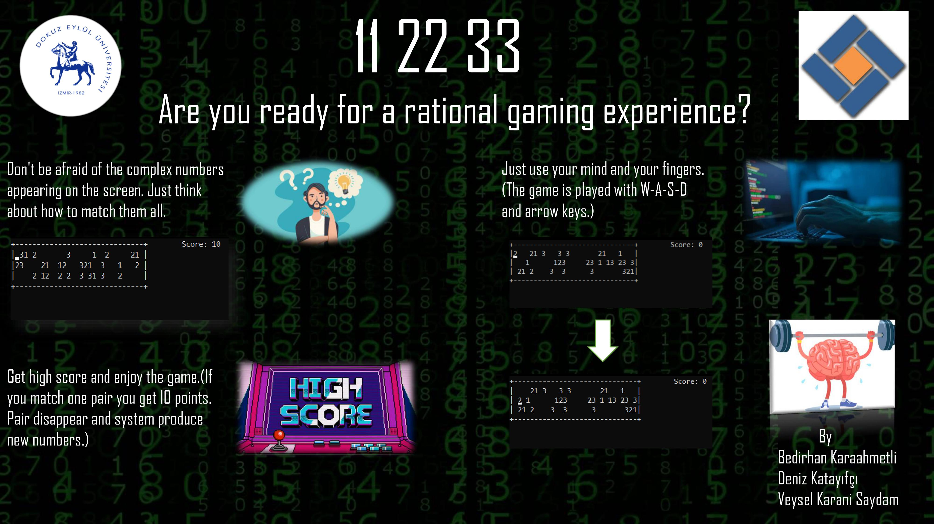

AppendIx B
Code of the Project
